Customization for Invoices
Esperar confirmacion del cliente.

Customer has an absolute pricing set for an item, which is for example 0.67.
For an item, they go to customer record and get 0.67, which is the absolute pricing.
Then, when customer goes to ERP, they create an invoice, and they change this price on ERP. So, when they go to my account, we check the invoices and we see the invoice price that’s not the one that they set on ERP for that invoice, not for all but just for this invoice.
So we have to show the price from the ERP invoice instead of the price from the absolute pricing.
The ask is to change that price below the name (0.67) there for the ERP invoice price:
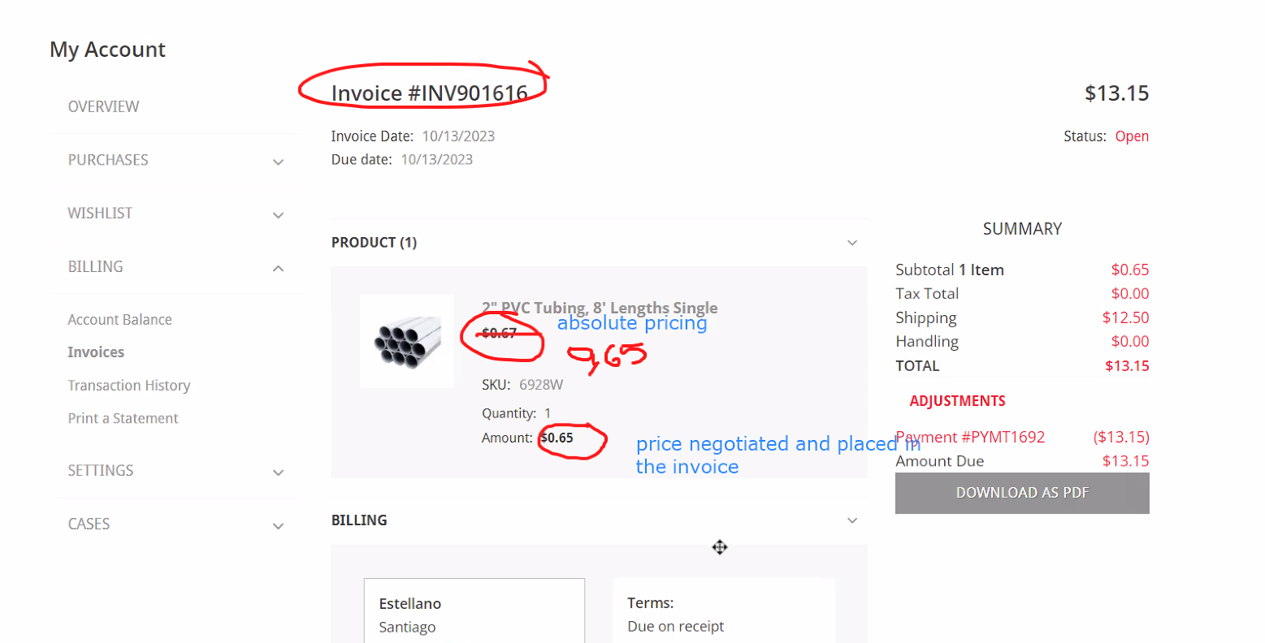

Their price from site is 0.67, but they negotiated for this particular invoice 0.65, but seems it shows the price from site which is 0.67.
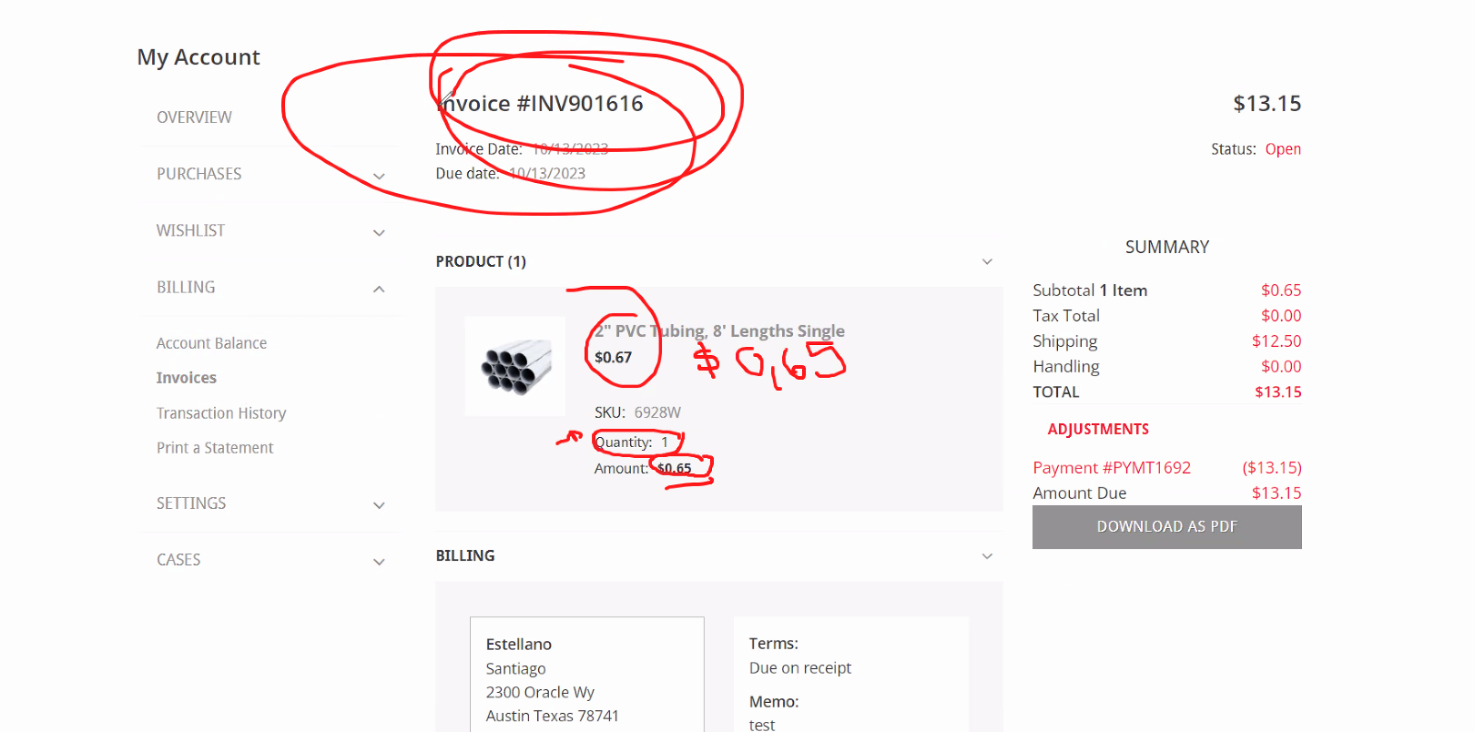
This is against native behavior.
It’s working correctly, but want to do something different.

Css get the amount and divide by the quantity,
problem with invoice and having more than 1 line.

Delete with css and add a child view doing -> Css get the amount and divide by the quantity,

Not 100% sure.
- to hide the price otherwise brings lot of problem

we do not have a solution, if I can spend X hours to test then I can give an estimation.
Pero quizas esas horas las quemamos y no sale nada.

Add to view context -> pass with a cancelable to the child view that will have the invoice info
Inside the child view you will need to know on which item you are, so you will need to select the info from the invoice.
data-id that has the id of the item.

addToViewContextDefinition, gets the invoice data, then you trigger a cancelable event and you pass the info to a child view.

What happens if they have for example same item red color, and then yellow color perhaps different price?

Por el momento, ocultarlo.
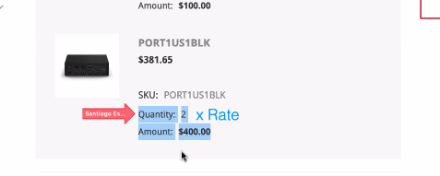
Y agregar esto.

Customization 2

If you are anonymous user occult all of this:
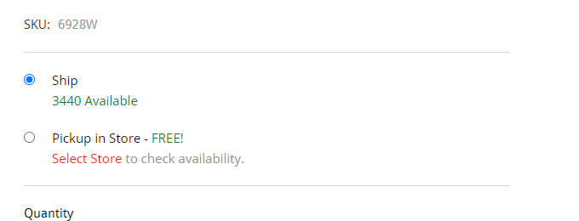
Ask client
Use:
layout.removeChildView('CreditCard.List');
and remove data-view: Product.Stock.Info

Customization 3
Hide “add to cart” button (10h) on PLP
user.getUserProfile().then(function getUser(profile) {
this.profile.isloggedin
});

